1) Write an assembly language program that stores a string in a variable. Now, first display the whole string and then display the first small letter and last small letter in the string. If no small letters are entered, then display “No small letters”.

Sample Input / Output: Input in a String: input_string DB ‘WE aRE DUET STuDeNTs’, 0Dh, 0Ah, ‘$’

Output: a

S

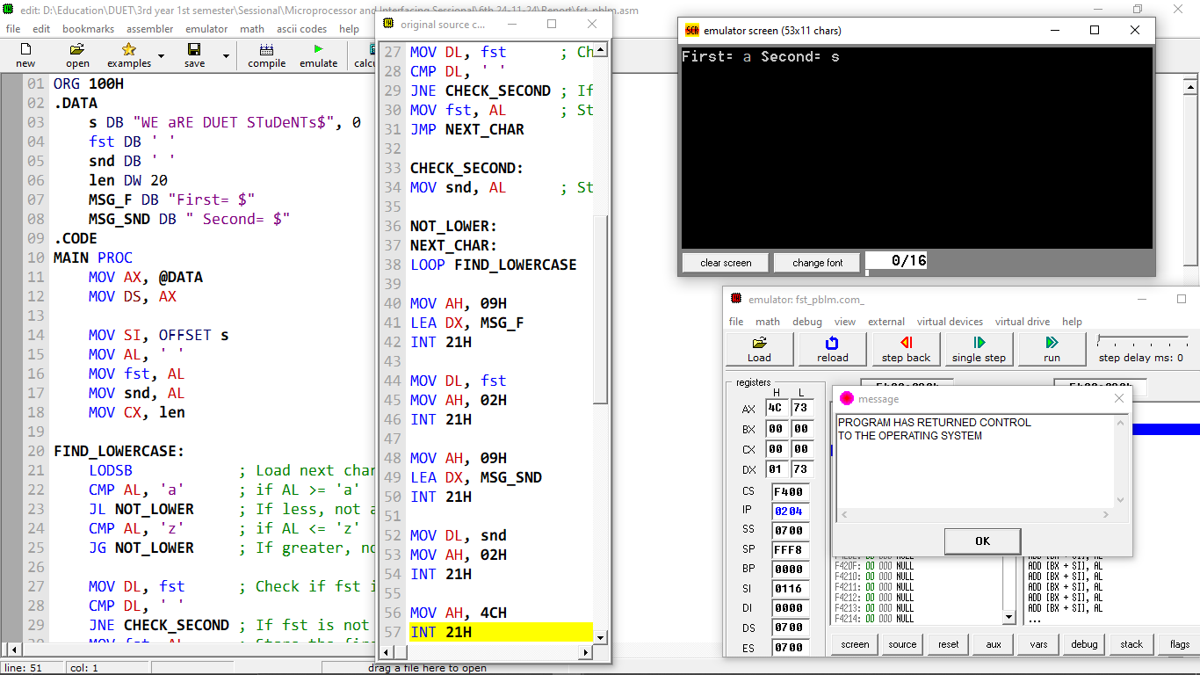

2) Write an assembly language code to derive the final value of the number sequence 1 2+22+32+42+…..+N2 . (use ARRAY and Loop). Take the input value of N (in between 2 to 9) as a single ASCII character and then adjust it to actual decimal value in your program. Finally, store and show the output in a variable named RESULT.

Sample Input / Output:

Input: The value of N in between 2 ~9 : 9

The result is: 285

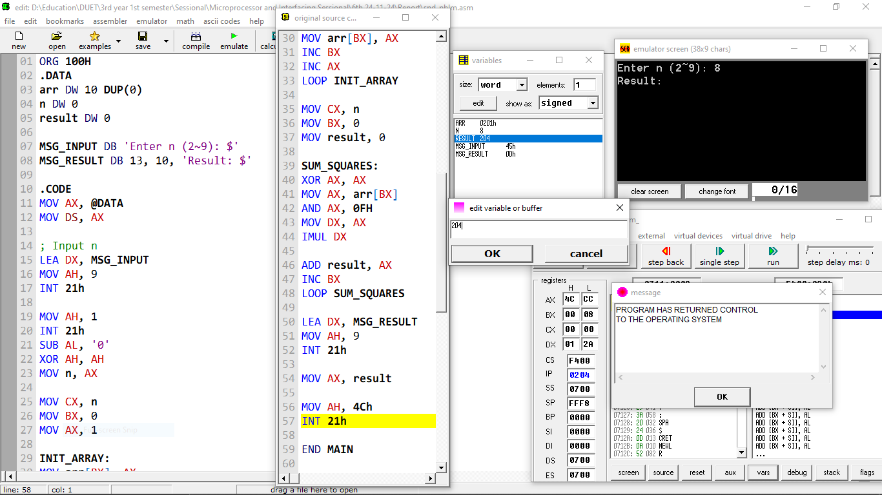

3) Write an assembly code to sort the following data in ascending order using any sorting algorithm.

Sample Input: Sample 2 6 1 9 4 Output: The sorted list is: 1 2 4 6 9

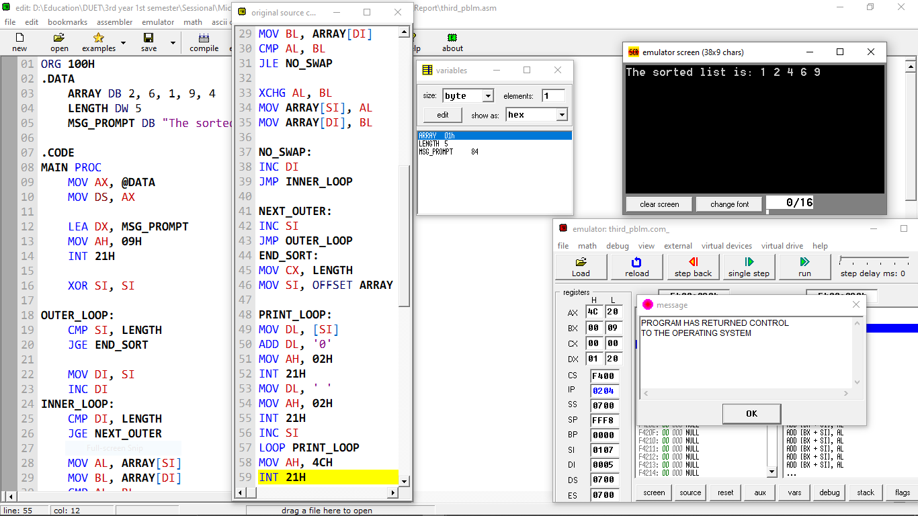

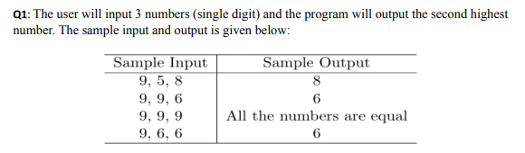

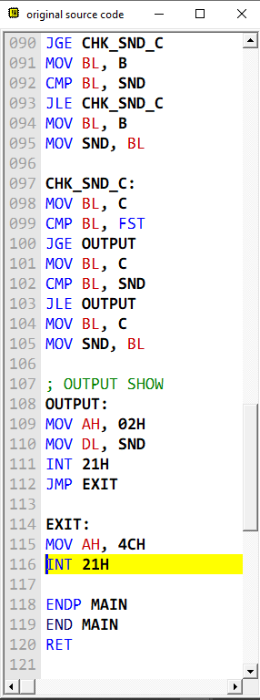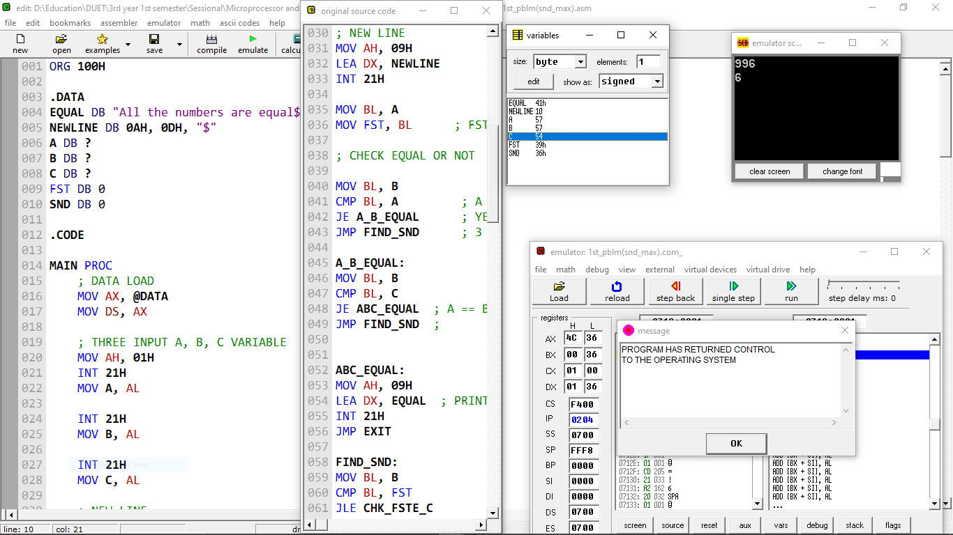

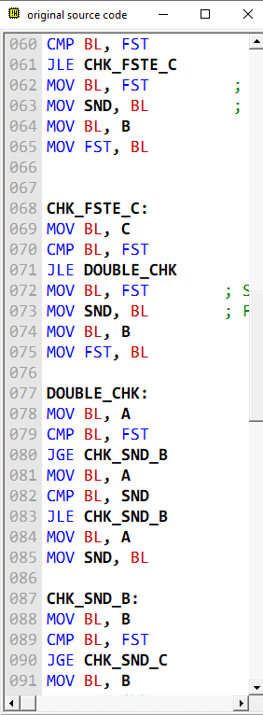

**Q2.** Write an assembly language code to derive the final value of the number sequence: -1+2-3+4-5+…..N. (Using Loop). Take the input value of N (in between 2 to 9) as a single ASCII character and then adjust it to the actual decimal value in your program. Finally, store the output in a variable named RESULT. You do not need to display the output in the console

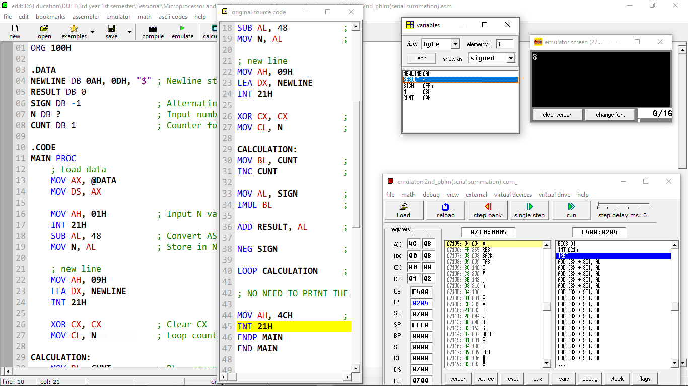

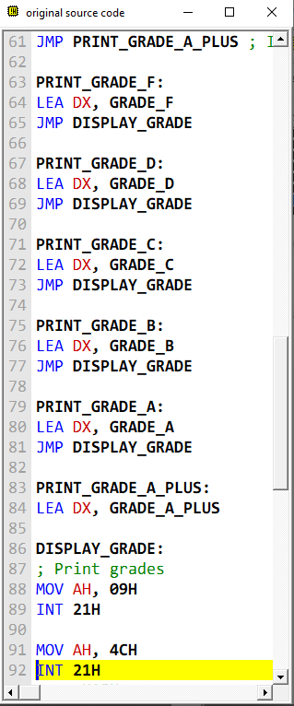**Q3:** First of all we will input a mark of the subject from the candidate and according to the following condition we will calculate the grade.

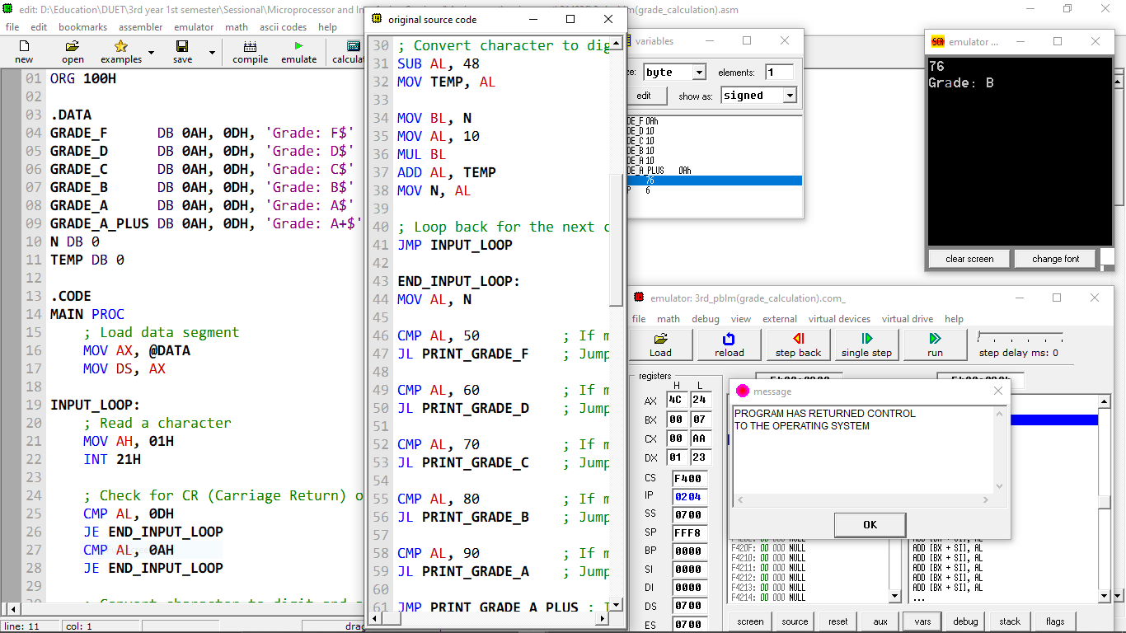Sample Input: 80 Ouput: Grade: A